Document Overview
This document provides cleanup options for Azure resources in the EMT DevTest subscription and proposes a strategic subscription restructuring approach.
Current State - the existing EMT DevTest subscription has become unorganized with mixed POC and development resources, making comprehensive cleanup complex and risky exercise.

Approach Options
Option A: Clean up existing EMT DevTest subscription in-place, apply controls, establish CorpNet, migrate resources into it and then create new EMT Sandbox subscription
Option B: Start immediate cleanup of low-risk resources, migrate development resources to new EMT DevTest subscription, and continue aggressive cleanup of current subscription as Sandbox
The recommended approach (Option B) involves immediate cleanup of low-risk resources in the current EMT DevTest subscription, followed by migration of development resources to a new EMT DevTest subscription, and continued cleanup of the remaining resources. The current EMT DevTest subscription should be renamed as EMT Sandbox subscription.

Why Option B is Better!

Immediate Cost Savings
- Start cleanup now with zero-risk items (empty resource groups, unused NSGs)
- Remove old unattached disks (90+ days) and empty app service plans
- Use activity logs as starting point, then verify with service owners before deleting rest of the resource

Clean Start for Development
- New Dev subscription = fresh start with proper governance
- No legacy naming issues or old configurations to inherit
- Implement best practices from day one

Network Setup is Easier
- Current subscription lacks corporate network connectivity
- Adding network to existing resources = major rework. All resources need rebuilding to use new network components
- New EMT Dev subscription can be built with proper networking from start
- Sandbox stays isolated (good for POCs), Dev gets corporate access

Things to take care with Renaming Subscription

Governance
- Billing and Cost Management: Reports may show old names (older time periods) and new names (post changes)
- IaaC templates: Using subscription name (not ID) may need updates
- CI/CD Pipelines: Using subscription name (not ID) may need updates
- PowerShell/CLI Scripts: Scripts using -SubscriptionName parameter instead of SubscriptionId should be updated

What continues to work
- All Azure resources and services (uses subscription ID internally)
- Azure RBAC assignments (tied to subscription ID)
- Azure Policy assignments (uses subscription ID)
- Resource deployments and management operations
- Azure Monitor, Log Analytics, and Application Insights
- Billing and invoicing (subscription ID remains same)

Since all resources are part of EMT DevTest subscription

Cleanup Categories

App Service Plans
- Purpose: Identifies empty App Service Plans with no hosted applications
- Criteria: properties.numberOfSites == 0
- Cost Impact: App Service Plans incur charges even when empty
- Cleanup Action: Delete unused plans or consolidate apps into existing plans
- Risk Level: LOW - No impact on running applications
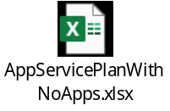

Empty Resource Groups
- Purpose: Finds resource groups containing no resources
- Criteria: Resource groups with null resource count
- Cost Impact: NONE - Resource groups are free. Stright forward to clean up
- Cleanup Action: Delete empty resource groups to reduce clutter
- Risk Level: NONE - No resources affected
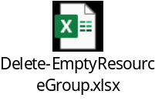

Empty Subnets
- Purpose: Identifies unused subnets in virtual networks
- Criteria: No IP configurations, delegations, or application gateway configurations
- Cost Impact: NONE - Subnets are free but consume IP address space
- Cleanup Action: Remove unused subnets to optimize network design
- Risk Level: LOW - Verify no future deployment plans
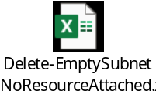

Unattached Disks
- Purpose: Finds orphaned managed disks (90+ days old)
- Criteria: Not managed by any VM and older than 90 days
- Cost Impact: Disks incur storage charges continuously
- Cleanup Action: Delete after verifying no backup/recovery needs
- Risk Level: MEDIUM - Ensure disks don't contain critical data
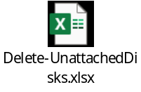

Unattached Network Interfaces
- Purpose: Identifies unused network interfaces
- Criteria: Not attached to VMs, private endpoints, or link services
- Cost Impact: Minimal charges but consume IP addresses
- Cleanup Action: Delete unused NICs to free IP addresses
- Risk Level: LOW - Verify not reserved for specific purposes
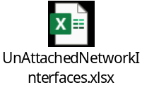

Unattached Network Security Groups
- Purpose: Finds NSGs not associated with any resources
- Criteria: Null network interfaces and subnets properties
- Cost Impact: NONE - NSGs are free but create management overhead
- Cleanup Action: Delete unused NSGs
- Risk Level: LOW - Verify not part of known creations/ deployments
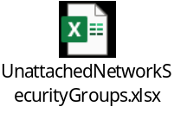

Resource – Activity Log
- Purpose: Analyzes last access patterns for all subscription resources
- Method: Queries Azure Activity Log excluding Microsoft.Advisor events
- Output: Comprehensive resource list with activity timestamps and API events
- Usage: Provides data-driven insights for cleanup impact assessment
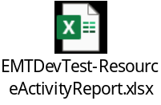

Precautions
- Check with resource owners before deletion
- Take snapshots of critical disks before deletion (mostly it should not be the case)
- Review activity logs for resources inactive > 90 days
  - Decision on resource deletion/ retention depends on this

